***Constelación de Historias: Community Storytelling in East Boston***

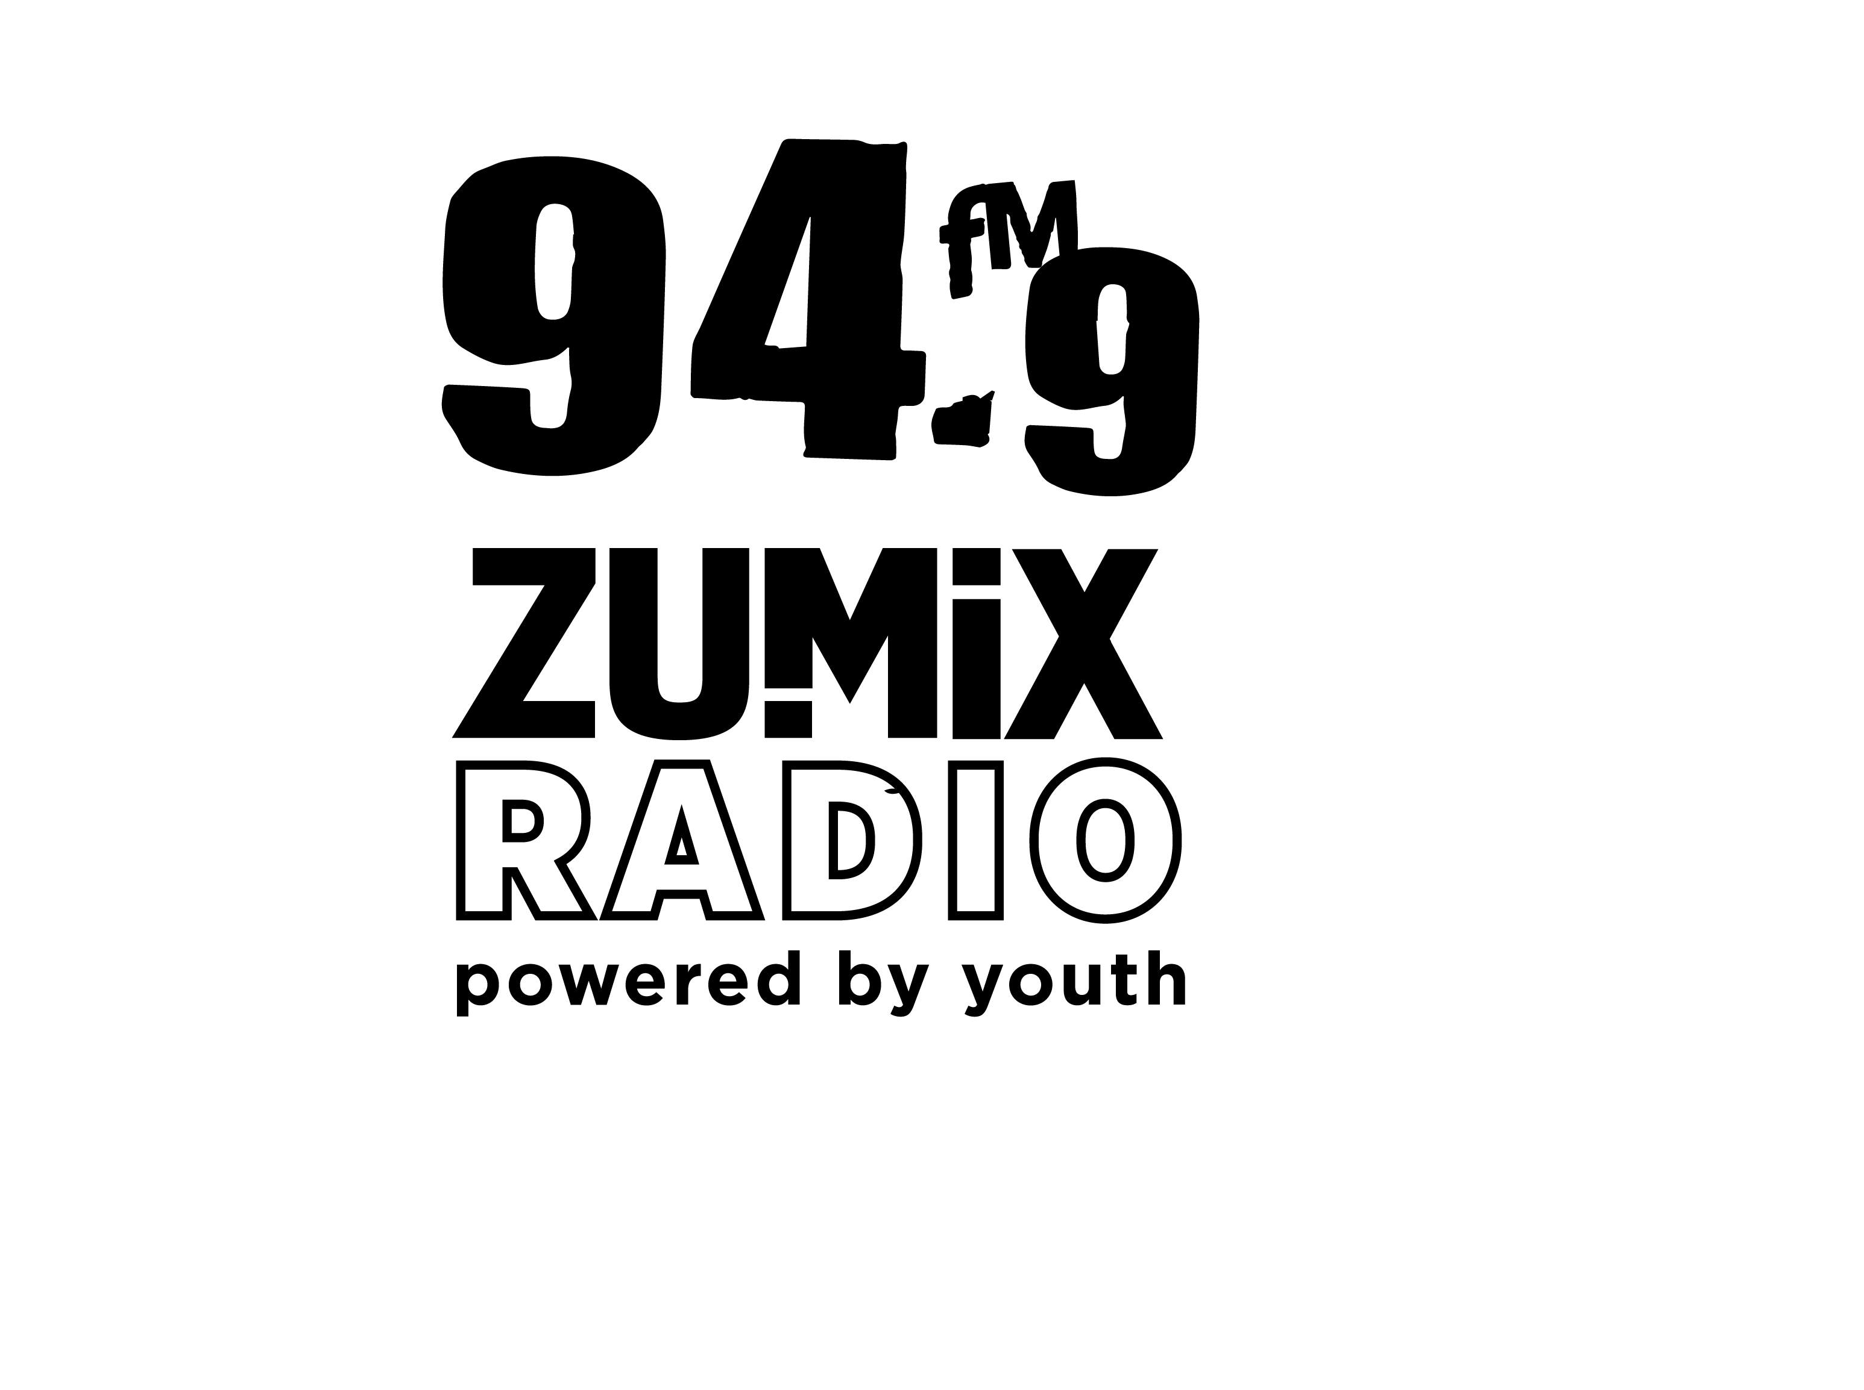

Brittany Thomas + Rene Dongo Handout

*Constelación de Historias* is a community storytelling project about life and housing in East Boston. During a time of rapid housing development in the neighborhood, *Constelación de Historias* brings neighbors together to create a locally produced narrative about the people that bring Eastie to life and their hopes for its future.

**Guiding Lights for the Project!**

1. “Reciprocity is key to wholesome community.” – Gabi Barroso, youth facilitator and audio producer. The foundation for this project is deep collaboration with other community based organizations in our neighborhood. How can artistry and creativity be useful in our collective fight for just housing? We’ve held regular meetings with collaborators, who’ve supported the outreach and facilitation of the live event series.
2. Youth and adult community members hold editorial control over the stories they publish. The design of each event is unique – featuring story workshops, an audio story map, and live storytelling. Across the different story modes, the content is created by many producers, assembling a constellation of real perspectives.
3. Good documentation gives power and longevity to our stories. We invest a lot of time into documenting the events through audio, video and photography. A part of working in solidarity with neighbors is validating current community work as part of the neighborhood’s history.
4. Language justice is necessary for community connection across lingual differences. All of our events are produced bilingually in English and Spanish – with consecutive interpretation where possible, so each language is equally present in the space.

**Timeline.** [check out the back side, for more planning details]

*July*: Collaborators convene to design timeline, goals and leadership of the project.

*August*: An Audio Challenge teaches new audio producers to record their own memories of Eastie. *September*: ZUMIX Radio Block Party offers a chance to reflect on neighbor-produced ‘boom box installations.’ *October*: Neighbors follow a Sound Walk map of Maverick Square, listening to place-specific audio.

*November*: Story Loft brings a local activist’s long-form story to the stage + feedback via zines!

**Documentation to Check Out.**

Videos Docs: https://vimeo.com/user90033856

Sound Walk Playlist: https://soundcloud.com/user-956472016/sets/constelacion-de-historias WBUR story: https://[www.wbur.org/artery/2018/11/07/east-boston-gentrification-zumix-stories](http://www.wbur.org/artery/2018/11/07/east-boston-gentrification-zumix-stories)

# july

**september**

**b l o c k p a r t y**

**october**

**s o u n d w a l k**

**august**

**a u d i o**

**c h a l l e n g e**

**november**

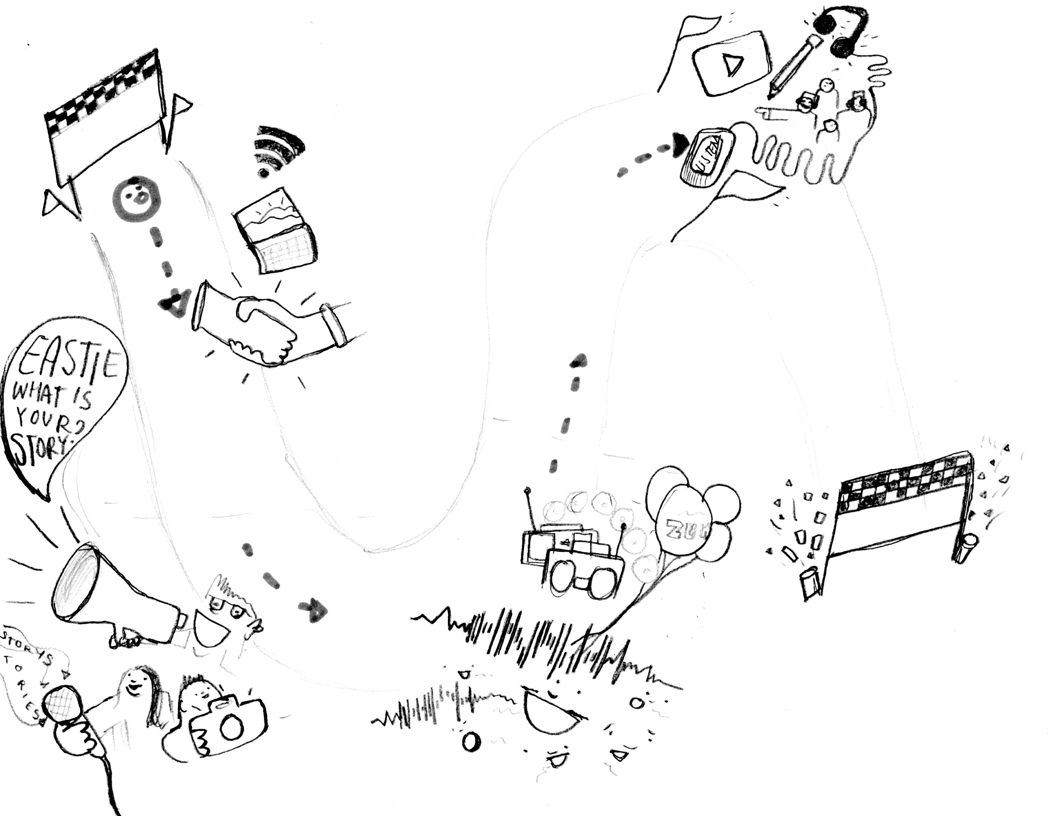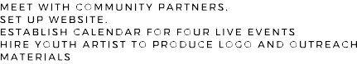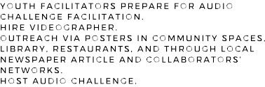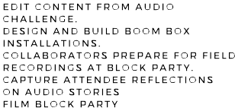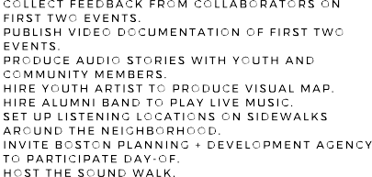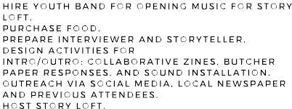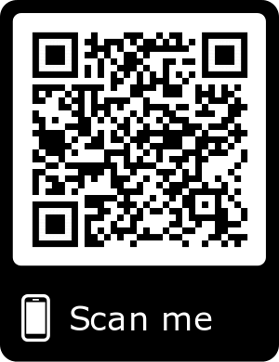

**s t o r y l o f t**